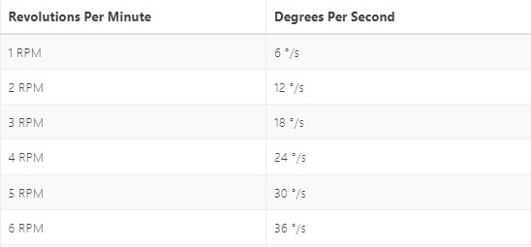**Mechanical Task1:**

As per requested to calculate the angle of the rotating leg we designed a 3D model of the robots legs and with the table above we see the best suitable motor is 5 RPM and it will give us a 30 Degree angle but the actual motor power will be the electric department.